Tasks for the Summative Assessment
9 Grade
Learning objectives:
9.4.2.1 Understand specific information and detail in texts on a growing range of familiar general and curricular topics, including some extended texts
9.6.3.1 Use a variety of compound adjectives and adjectives as participles and a variety of comparative structures to indicate degree on a range of familiar general and curricular topics

Assessment criteria:
• Realize particular facts and parts in reading passage
• Employ the rule for using adjectives

READING
Task 1. Read and choose TRUE, FALSE or DOESN’T SAY.
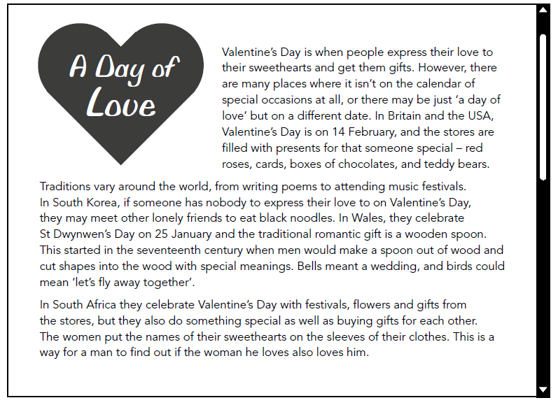

1. Valentine’s Day is on 14 February all around the world. _______

2. South African men write their names on the sleeves of the women they love. _______

3. In one country people eat noodles to show their love. _______

4. Shopping for gifts is part of Valentine’s Day traditions in the USA. _______

5.South African men buy clothes as gifts for the women they love. _______

USE OF ENGLISH. GRAMMAR
Task 2. Choose the correct answer

1. Choose the correct answer: She is ..... performer in the world.
A) greatest
B) the great
C) the greatest
D) more great
E) more greatest

2. Choose the correct answer: I haven't got ..... money to buy tickets.
A) too
B) most
C) to
D) enough
E) very

3. Find the wrong sentence.
A) The concert was disappointing and we didn't enjoy it.
B) The children are really excited about visiting the amusement park!
C) The website was confused and I couldn't book the tickets.
D) I was so bored during the parade that I almost fell asleep.
E) The carnival was brilliant, but I am so tired now!

4. Choose the correct sentence.
A) There is any milk in the fridge.
B) Would you like a little biscuits?
C) How much apples have we got?
D) Can you get me a few butter?
E) There is a lot of meat left.

5. Choose the correct answer: Are there ..... tickets left for the show on Saturday night?
A) some
B) any
C) much
D) a
E) an

6. Choose the correct answer: The rooms are divided by a ..... wall.
A) thin, square, brown, brick
B) square, thin, brown, brick
C) thin, square, brick, brown
D) square, brick, thin, brown
E) thin, brick, square, brown

7. Choose the correct answer: The song they’ve just recorded is ...... their other hits.
A) more nice than
B) nicer as
C) nicer than
D) more nicer as
E) nice

8. Choose the correct answer: Isn't his book ...... than those we've read so far?
A) more funny
B) funny
C) more funnier
D) funnier
E) funier
9. Find the wrong sentence.
A) The concert was held in the grounds of a beautiful, big, old palace.
B) She is young, talanted, Kazakh singer.
C) Do you like my lovely, new, blue boots?
D) He learned to play on a little, old, wooden guitar.
E) La Tomatina is a fantastic, traditional, Spanish festival.

10. Choose the correct sentence.
A) It is a well-written script.
B) The cinema shows films from the early twentieth-century.
C) We camped overnight at the two day festival.
D) A five year old boy won the singing competition!
E) The full-length of the song is 26 minutes.

Assessment criteria | Task | Descriptor | Mark
 |  | A learner
Realize particular facts and parts in reading passage. | 1 | 1.F | 1
 |  | 2. F | 1
 |  | 3. F | 1
 |  | 4. T | 1
 |  | 5. DS | 1
Employ the rule for using adjectives | 2 | 1. C | 1
 |  | 2. D | 1
 |  | 3. C | 1
 |  | 4. E | 1
 |  | 5. B | 1
 |  | 6. A | 1
 |  | 7. C | 1
 |  | 8. D | 1
 |  | 9. B | 1
 |  | 10. A | 1
Total marks |  |  | /15

