Task 1

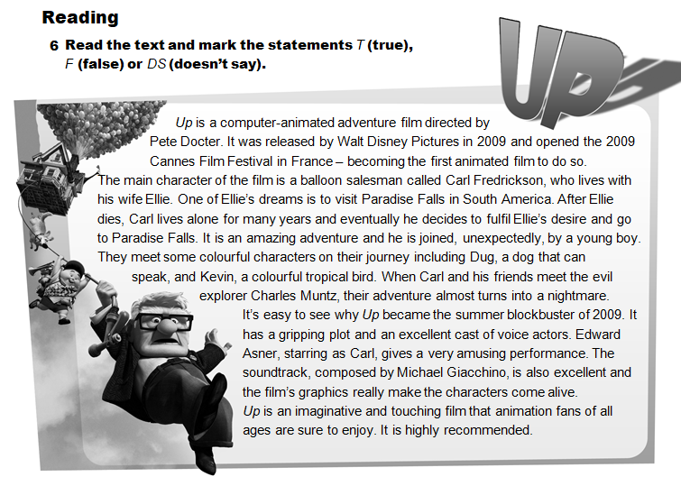
1 Up was made in the USA. …DS……..
2 The main character of the film is a doctor. …F……..
3 Carl travels with Ellie to Paradise Falls. …F……..
4 Carl doesn’t meet any people on his way to Paradise Falls. …F……..
5 Michael Giacchino wrote the music for the film. …T……..
6 The writer thinks Up is a great film. …T……..
7 The writer believes that the film is only suitable for children. …F……..

Task 2 Choose the correct item.
1 Do you know when they will release the new Harry Potter film?
2 Modern science-fiction films have excellent sound effects.
3 It’s a great film that is sure be a summer blockbuster.
4 We should go and see Monsters vs Aliens. It’s highly recommended.
5 Hugh Jackman plays Wolverine in the X-Men films.

Task 3
- Who was the music for the ballet The Nutcracker composed …? Tchaikovsky. By
- The Golden Globe awards ceremony … last week. Was held
- The film … to win an Oscar this year. Is expected

